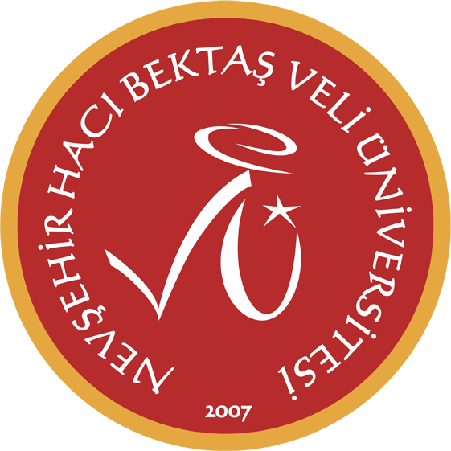
2025 - 2026 Güz Dönemi
Selda Demir

 | Pazartesi | Sali | Carsamba | Persembe | Cuma
08:30 09:15
09:30 10:15 |  | MC - ENGLISH PREPARATORY (SPC E)  H1 | MC- ENGLISH PREPARATORY (SPC B)  YDYO 2 | MC - ENGLISH PREPARATORY (SPC E)  H1
10:30 11:15 |  | MC - ENGLISH PREPARATORY (SPC E)  H1 | MC- ENGLISH PREPARATORY (SPC B)  YDYO 2 | MC - ENGLISH PREPARATORY (SPC E)  H1 | MC- ENGLISH PREPARATORY (ELT B)  YDYO-12
11:30 12:15 | MC- ENGLISH PREPARATORY (SPC B)  YDYO 2 | MC - ENGLISH PREPARATORY (SPC E)  H1 | MC- ENGLISH PREPARATORY (SPC B)  YDYO 2 | MC - ENGLISH PREPARATORY (SPC E)  H1 | MC- ENGLISH PREPARATORY (ELT B)  YDYO-12
12:30 13:30
13:30 14:15 | MC- ENGLISH PREPARATORY (SPC B)  YDYO 2 |  |  | MC- ENGLISH PREPARATORY (ELT B)  YDYO-12 | MC- ENGLISH PREPARATORY (SPC B)  YDYO 2
14:30 15:15 | MC - ENGLISH PREPARATORY (SPC E)  H1 |  |  | MC- ENGLISH PREPARATORY (ELT B)  YDYO-12 | MC- ENGLISH PREPARATORY (SPC B)  YDYO 2
15:30 16:15 | MC - ENGLISH PREPARATORY (SPC E)  H1 |  |  |  | MC- ENGLISH PREPARATORY (SPC B)  YDYO 2
16:30 17:15
17:30 18:15

